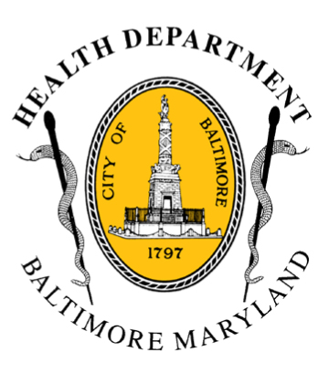
BCHD PRESS RELEASE
Baltimore City Health Department
1001 E. Fayette Street • Baltimore, Maryland 21202
Stephanie Rawlings-Blake, Mayor
Leana Wen, M.D., Commissioner of Health

FOR IMMEDIATE RELEASE
Media Contacts:

Michael Schwartzberg, PIO
O: (443) 984-2623 C: (443) 462-7939 E: michael.schwartzberg@baltimorecity.gov

Preventing Tobacco Sales To Underage Children
Is Just A (311) Phone Call Away

BALTIMORE, MD (August 21, 2015) – Baltimore residents can now help health officials to work on the life-changing problem of tobacco use with a simple phone call. Today, Mayor Stephanie Rawlings-Blake and Health Commissioner Dr. Leana Wen announced a new tool in the fight against sales of tobacco to underage youth.

Individuals can now call 311 to report businesses that are selling tobacco to youth under age 18, and Health Department officials will investigate each complaint. The Health Department has launched a public education campaign, with messaging inside buses and radio advertisements encouraging individuals to call 311.

“Our citizens are already very familiar with using 311 to let city officials know about many issues, so this is a natural extension of this customer service initiative,” Mayor Rawlings-Blake said. “We need everyone’s help to protect our children from a lifelong addiction to tobacco.”

Under state law, all individuals under age 27 who attempt to purchase tobacco products must be asked to produce photo identification to verify their age. Recent data shows that nearly 37 percent of underage youth who attempted to purchase tobacco products in Baltimore City were able to do so.

“Nine out of 10 smokers start before the age of 18 and thousands of these individuals will die every year from tobacco-related diseases,” said Dr. Leana Wen, Baltimore City Health Commissioner. “Stores that are selling tobacco to our youth is not only a legal issue, but one that will cost people their lives.”

More than 1,600 retail establishments in Baltimore are licensed to sell tobacco products, the largest number of licenses cigarette retailers of any jurisdiction in the state. It is illegal to sell tobacco products to anyone under age 18 under the city’s health code; violators face fines of $500 for a first offense.

- more-

2-2-2

In FY2014, Baltimore health officials performed more than 1,100 education visits and compliance checks at businesses, including 450 youth compliance checks where youth under 18 are employed to attempt to purchase tobacco products. 79 citations were written as a result of all checks.

Thalia Jamison has owned the Asburton Mini Mart in the 600 block of Ashburton Street for 10 years and is one of only a few African-American female corner store owners in Baltimore. Her store has routinely passed undercover tobacco inspections.

“I’ve had several family members die of lung cancer and related diseases,” Jamison said. “Tobacco kills, so this issue really hits home for me.”

For FY 2015, BCHD has expanded its undercover enforcement efforts, hiring two new part-time enforcement officers (total of three employed) and planning additional enforcement “sting” operations.

The Health Department is also increasing its education and outreach efforts with retailers across the city:
- In addition to the education already provided by the enforcement team, the program contracted with two community-based organizations to perform one-on-one education about local tobacco control laws with retailers in their communities.
- Enhanced relationships have been developed with the city’s Environmental Control Board to ensure that fines are not reduced on appeal and with the State Comptroller’s Office to impose sanctions against a tobacco retailer’s state license for repeat local (city) violations.
- The program is also working with a communications firm on developing anti-tobacco educational materials tailored to Baltimore City youth.

“It’s not enough to educate our youth if we have stores that will sell tobacco illegally to underage kids,” said Dr. Wen. “We need stronger penalties to those who sell to youth, and we need everyone’s help to identify stores that are breaking the law. Together, Baltimore citizens can make a difference.”

Statistics:

- Every day, more than 2,800 youth in the United States try their first cigarette.
- Unless current smoking rates decline, 5.6 million kids alive today will ultimately die from smoking related diseases.
- In Baltimore, 17 percent of high school students and 12 percent of middle school students reported using tobacco products for the first time last year.
- According to the Youth Risk Behavior Survey, Baltimore City youth try smoking at an earlier age than their peers across the state.
###

